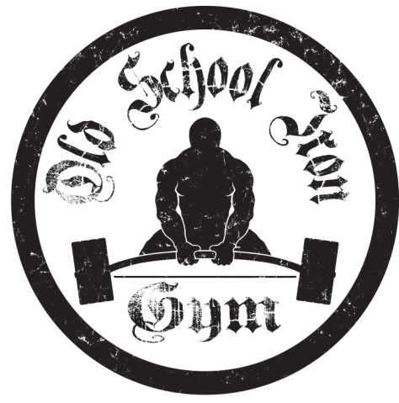
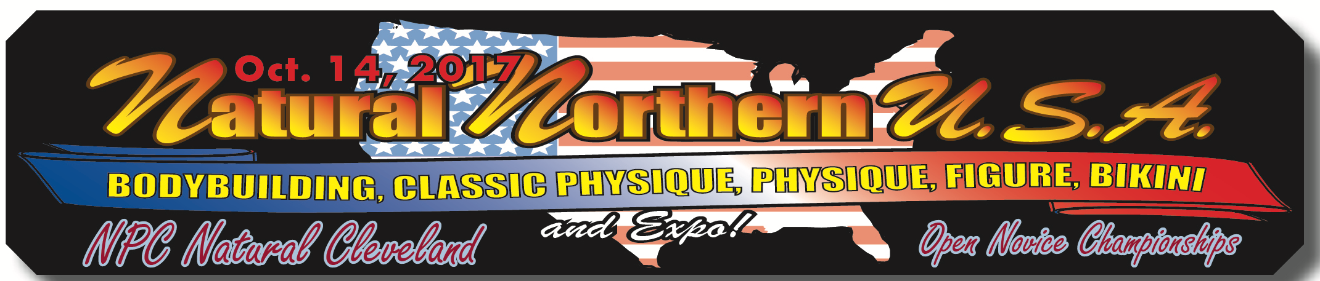

Old School IronGym
Presents:
NORTHERN USA PUSH / PULL CHAMPIONSHIPS
Saturday October 14th 2017
Cleveland Public Auditorium
500 Lakeside Avenue
Cleveland, Ohio 44114
216-322-7264

This is a unique event that will be held in the EXPO of the NPC Natural Northern USA Bodybuilding Championships!

With purchase of a ticket to the event, you will have access to all of the vendors, concessions, push/pull championship, bodybuilding competition, and much more!!!

Entry to Event Tickets: (Separate from Entry Fee for the Push/Pull Meet)

$20.00 Advanced Tickets

(Available at Old School Iron Gym 5139 W. 140th Brook Park, OH 44142 or call 216-322-7264 for further details OR online at www.daveliberman.com).
$25.00 Day of Event

Entry Fee:

$70.00 Push / Pull
$40.00 Bench Only
$40.00 Deadlift Only

Age Divisions: (ALL DIVISIONS RAW)

Male / Female: 12-19
Male / Female: 20-29
Male / Female: 30--39
Male / Female: 40-49
Male / Female: 50-59
Male / Female: 60+
Weight Classes:

Women- 114, 123, 132, 148, 165, 181, HW.
Men- 114, 123, 132, 148, 165, 181, 198, 220, 242, 259, 275, 308, SHW.

Weigh-In:

Evening weigh-ins will be conducted Friday October 13th from 5pm to 8pm at Old School Iron Gym 5139 W. 140th Brook Park, Ohio 44142.

Rules meeting will be held at 9:15am with lifting starting promptly at 10:00am.

Equipment:

Belt and wrist wraps only. Bring all gear to weigh in for approval.

Entry Deadline:

Saturday September 30th. 2017
Cash or Money Order
Old School Iron Gym
C/O: Tom Slomka
5139 W. 140th
Brook Park, Ohio 44142
216-322-7264 (Luz Miller)
osigym@yahoo.com

Individuals who wish to enter after the deadline or Friday October 13th at Check-In's, must add a $10.00 late fee and will receive a meet shirt and/or trophy based on availability.
**There is NO entry excepted day of meet, Saturday, Oct 14th!!*

Awards:

Trophies will be presented for 1st place in all classes and divisions. Medals given for 2nd place.

All awards will be presented at the conclusion of the meet, if you are unable to stay for trophy presentation, please make arraignments. No awards will be given prior to trophy presentation.

Push / Pull Championships

Name:_________________________________________________Age:________ Sex:________
Address:____________________________________ Email:_________________
City:_______________________________________________ State:____________ Zip:____________
Weight Class:____________________Phone Number:______________________

Please list some personal information about yourself in the lines provided for our announcer. You may include anything from your achievements, occupation, years training, the gym you’re representing (and where it is located).

Gym Name:_________________________________________________________

Personal Information:__________________________________________________________________________________________________________________________________________________________________________________________________________________________________________________________________________________________________________________________________________________________________________________________________

Age Divisions: (ALL DIVISIONS RAW)

Male / Female: 12-19
Male / Female: 20-29
Male / Female: 30--39
Male / Female: 40-49
Male / Female: 50-59
Male / Female: 60+

Weight Classes:

Female- 114, 123, 132, 148, 165, 181, HW
Male- 114, 123, 132, 148, 165, 181, 198, 220, 242, 259, 275, 308, SHW

Waiver

My signature below confirms that I have read this waiver and agree and understand that I am competing in Old School Iron Gym Push / Pull Championships held at 500 Lakeside Avenue Cleveland, Ohio 44114 under my own free will and therefore at my own risk. In the event an injury should occur, I expressly waive any legal rights I may have and promise that I will not hold any member of Old School Iron Gym, Todd Pember, Dave Liberman, NPC Natural Northern USA, the NPC Natural Novice Cleveland, The City of Cleveland, or anyone affiliated with this meet in any way liable or responsible for any injury to my person or property.

Signature (Parent or guardian if under 18):

Mail / drop off entry forms with cash or money order to:

Old School Iron Gym
C/O: Tom Slomka
5139 W. 140th
Brook Park, Ohio 44142
216-671-7505
osigym@yahoo.com
www.osigym.com

* Push/Pull Event is solely owned and operated by Old School Iron Gym

